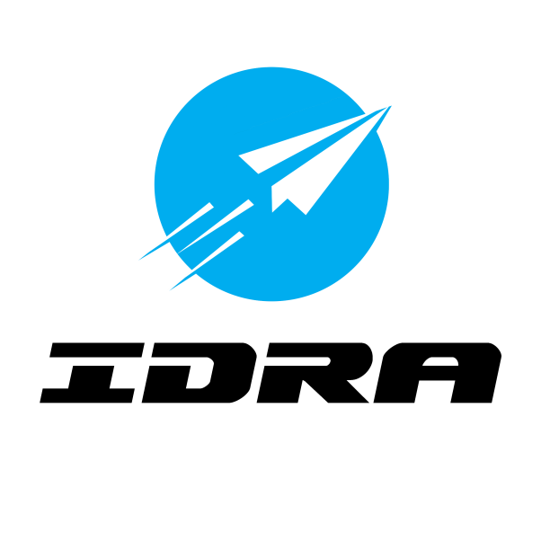

FOR IMMEDIATE RELEASE Contact: Justin Haggerty
April 10, 2017 (734) 740-9715

Dover International Speedway to Host USA Race of the
IDRA Drone Racing Series in 2017, 2018 and 2019

BELLEVILLE, Mich. – The International Drone Racing Association (IDRA) has announced a new partnership with Dover (Del.) International Speedway. The IDRA will hold its USA event at the track famously known as “The Monster Mile” June 2-4, 2017, in conjunction with their NASCAR tripleheader race weekend. The event will be free and open to the public to watch in Dover’s FanZone.

The race will feature 16 professional teams from around the world, competing to earn points toward the World Championship. The three-year agreement provides IDRA with the opportunity to showcase the growing sport of drone racing in Dover during its spring event weekend.

“Dover International Speedway is an incredible opportunity for IDRA,” said Justin Haggerty, the founder and CEO of IDRA. “Showcasing the sport, during a major NASCAR weekend, to over tens of thousands of motorsports fans is the best opportunity that IDRA could ask for. To IDRA, the drone racing community is the sport’s most valuable asset and it is set to grow after the Dover race.”

“We’re excited to host an IDRA event in Dover,” said Mike Tatoian, Dover International Speedway president and CEO. “The Monster Mile provides race fans in the mid-Atlantic with a chance to experience NASCAR in person, and we’re looking forward to introducing those same passionate fans to a different kind of racing during our June 2-4 event.”

The 2017 IDRA Drone Racing Series is a professional series of six international events. The season begins in the United States and concludes with the IDRA Finals in Amsterdam. Contestants compete for the IDRA Drone Racing Series World Championship on the basis of total points earned at IDRA international events, including the IDRA Finals.

UAS/Drone racing is a worldwide sport that utilizes Unmanned Aircraft Systems (UAS) and Virtual Reality (VR) technology to allow a new breed of innovators to compete on the international stage. There are roughly 100 drone competitions in the U.S. annually and 200 worldwide competitions, highlighted last year by IDRA’s World Drone Prix in Dubai that awarded its first $1 million prize to a 15-year-old from the United Kingdom in 2016.

For tickets or more information about race weekend, call 800‐441‐RACE or visit DoverSpeedway.com. You can also keep up with the Monster Mile at Facebook.com/DoverInternationalSpeedway, or on Twitter and Instagram at @MonsterMile.

About the International Drone Racing Series

The International Drone Racing Association (IDRA) is a for-profit association founded on the belief that competition drives innovation, and that drone racing is the next evolution of robotic competition. IDRA believes in growing this awesome new industry by organizing historic drone racing competitions like the semi-professional Challengers Cup and professional Drone Racing Series. The IDRA’s core mission is to grow this amazing community of tinkerers, dreamers, and innovators.

Website: www.idra.co
Facebook: https://www.facebook.com/droneracingassociation/
Twitter: https://twitter.com/idradroneracing
Instagram: www.instagram.com/droneracing
YouTube: https://www.youtube.com/channel/UCYGnsbWeH9BC7FitZ5R91Uw
Social media hashtags: #IDRA #DroneRacing #Drones #Racing #Esports #VirtualReality

About Dover Motorsports, Inc.

Dover Motorsports, Inc. (NYSE: DVD) is a leading promoter of NASCAR sanctioned motorsports events whose subsidiaries own and operate Dover International Speedway in Dover, Del. and Nashville Superspeedway near Nashville, Tenn. The company also plays host to the Firefly Music Festival, produced by Red Frog Events and Goldenvoice. For more information, visit www.DoverMotorsports.com.

